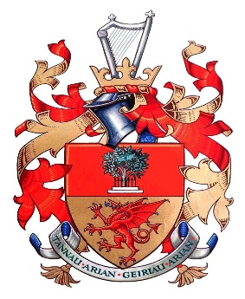 | CYNGOR TREF  CAERWYS  TOWN COUNCIL

Before completing this nomination form, please peruse the Council’s Award Policy.

Please either complete on-line, save and attach to an e-mail to Clerk - or print hard copy and post / deliver to Clerk’s home address:

R. Phillip Parry,
Clerk To Caerwys Town Council,
Ty Cornel,
51 St Michael’s Drive,
Caerwys,
Flintshire, CH7 5BS.
Tel: 01352 – 720547
E-mail: town-clerk@caerwys.com

Closing date: 12 Noon on Monday 10th July, 2023

Nominations will be considered by Council on: Tuesday 18th July, 2023

***************************************************************************************
I would like to nominate for a Community Award

Nominee's Name:

Nominee's Address

REASON (no more than 250 words): Please describe the contribution to the community made by this
person including the nature of their contribution, how long this has been for, and who has benefited

Next page
Click above line to expand box

NOMINEE’S DETAILS

Signature:
(only required if providing a hard copy)

Name in full:

Home address:

Tel no:

E-mail address:

